

**RECOMMENDATION SYSTEMS FOR ONLINE LEARNING PLATFORMS**

**A PROJECT REPORT**

Submitted by

**G. REETU (192212112)**

**N. SWAPNA SREE (192220029)**

Under the guidance of

**DR R DHANALAKSHMI**

In partial fulfilment for the completion of course

**CSA0279-C PROGRAMMING FOR BEGINNERS**

**TITLE:**

**Recommendation Systems for Online Learning Platforms**

**PROBLEM STATEMENT:**

As online learning platforms continue to grow in popularity, the sheer volume of courses, tutorials, and resources can overwhelm learners, making it difficult for them to find content tailored to their specific interests and needs. A personalized recommendation system can address this challenge by suggesting relevant courses based on user preferences, learning history, and behavior, thereby improving user engagement and learning outcomes.

**TASKS:**

* User profile creation with details on interests, skill level, and learning goals.
* Tracking of user activity, such as courses enrolled in, completed, and rated.
* Implementation of recommendation algorithms to suggest relevant courses.
* A feedback mechanism for users to rate and provide input on recommended courses.
* Real-time updates on recommended courses based on changing user preferences and behavior.
* Display of trending and popular courses across the platform.

**OUTCOME:**

The outcome of this project is to develop a Recommendation System for Online Learning Platforms that provides personalized course suggestions to users, helping them discover content aligned with their skills, goals, and interests. By leveraging machine learning algorithms, the system will analyse user activity, feedback, and course content to make tailored recommendations, thereby enhancing the user experience and encouraging continuous learning.

**AIM:**

* To develop a recommendation system for online learning platforms that provides personalized course suggestions based on user preferences, activity, and feedback.
* To provide course suggestions uniquely tailored to individual user preferences, skills, and goals.
* To help users quickly discover relevant and valuable courses, reducing the time spent searching for content.
* To encourage active participation by presenting users with recommendations aligned with their interests.
* To develop a system capable of updating suggestions in real-time based on user behavior and feedback.
* To analyze large datasets of user activity and feedback, enabling data-driven recommendations.

**ABSTRACT:**

The growing popularity of online learning platforms has led to an overwhelming increase in the number of courses, tutorials, and resources available to users. As a result, learners often face difficulties in discovering relevant content that aligns with their specific interests and needs. This challenge can result in disengagement and suboptimal learning experiences. A personalized recommendation system can address this problem by suggesting content tailored to the individual learner’s preferences, learning history, and behavior, thus enhancing the overall learning journey.

The proposed solution aims to develop a recommendation system that uses data-driven techniques to provide personalized course suggestions. By analyzing user interactions and preferences, the system will dynamically adapt and recommend courses that are most relevant to the learner. The system will also incorporate machine learning algorithms to continuously improve its recommendations based on evolving user behavior and feedback.

This project seeks to improve user engagement, retention, and learning outcomes by offering a more streamlined and customized learning experience. The personalized recommendations will help users efficiently navigate vast course offerings, reducing decision fatigue and improving content relevance. Ultimately, this approach aims to create a more satisfying and effective online learning environment that supports learners in achieving their educational goals.

**INTRODUCTION:**

With the rapid growth of online learning platforms, the sheer volume of available courses, tutorials, and educational resources has made it increasingly difficult for users to find content that aligns with their specific interests, goals, and learning needs. This information overload can lead to frustration, decreased engagement, and suboptimal learning outcomes. To address this challenge, there is a growing need for intelligent systems that can personalize the learning experience by offering tailored course recommendations.

A personalized recommendation system can help by analyzing user data, such as preferences, learning history, and behavior, to suggest content that is most relevant to the individual. By doing so, the system can enhance user satisfaction, engagement, and overall learning effectiveness. This approach not only helps users navigate vast course catalogs more efficiently but also fosters a deeper connection with the learning material, leading to improved learning outcomes.

The goal of this project is to develop and implement a personalized recommendation system for an online learning platform. By leveraging machine learning and data-driven techniques, the system will dynamically adapt to each learner’s unique needs, ultimately improving user engagement, course discovery, and educational success.

**CODE IMPLEMENTATION:**

To implement a personalized recommendation system for an online learning platform, the following modules would typically be involved:

**1. Data Collection and Preprocessing Module**

* **Objective:** Gather and preprocess data related to users, courses, and interactions.
* **Functions:**
  + **User Data:** Collect user profile data (e.g., age, interests, past course completions, etc.).
  + **Course Data:** Collect metadata of courses (e.g., course topics, difficulty level, course length, etc.).
  + **Interaction Data:** Record user behavior (e.g., clicks, time spent on courses, ratings, reviews).
  + **Preprocessing:** Clean and normalize the data (e.g., remove missing values, normalize ratings).

**2. Feature Engineering Module**

* **Objective:** Generate features that will be used for model training and predictions.
* **Functions:**
  + **User Features:** Extract features like preferred course type, learning style, historical activity, etc.
  + **Course Features:** Extract features such as course popularity, content type, skill level, and user ratings.
  + **Behavioral Features:** Create features based on user interaction data (e.g., most viewed courses, engagement patterns).

**3. Recommendation Algorithm Module**

* **Objective:** Implement and train machine learning models to generate personalized course recommendations.
* **Functions:**
  + **Collaborative Filtering:** Use user-item interactions (e.g., course ratings) to suggest courses based on user similarity or course similarity.
  + **Content-Based Filtering:** Recommend courses similar to ones the user has interacted with based on course content or metadata.
  + **Hybrid Approach:** Combine collaborative and content-based methods to improve recommendation accuracy.
  + **Matrix Factorization:** Decompose interaction matrices to find latent factors (e.g., Singular Value Decomposition (SVD)).

**4. Evaluation Module**

* **Objective:** Evaluate the effectiveness of the recommendation system.
* **Functions:**
  + **Metrics Calculation:** Compute recommendation system performance metrics (e.g., precision, recall, F1-score, RMSE).
  + **Cross-validation:** Use techniques like k-fold cross-validation to assess model performance on unseen data.
  + **A/B Testing:** Test different algorithms or approaches to compare results and improve recommendations.

**5. Personalization Engine Module**

* **Objective:** Generate dynamic, personalized recommendations for each user.
* **Functions:**
  + **User Profiling:** Based on user interactions, create a unique profile that informs course suggestions.
  + **Real-Time Recommendations:** Generate personalized course suggestions based on real-time data (e.g., recent activities, newly added courses).
  + **Contextual Recommendations:** Incorporate context (e.g., current course enrollment, learning progress) into the recommendations.

**6. Feedback and Adaptation Module**

* **Objective:** Continuously improve recommendations based on user feedback and evolving behavior.
* **Functions:**
  + **User Feedback:** Collect and analyze user ratings, reviews, and preferences for courses.
  + **Model Update:** Periodically update recommendation models to reflect changes in user behavior and preferences.
  + **Cold Start Problem Handling:** Implement strategies for recommending content to new users or courses (e.g., content-based filtering for new users).

**7. User Interface (UI) and Interaction Module**

* **Objective:** Interface for users to interact with the recommendation system.
* **Functions:**
  + **Recommendation Display:** Show recommended courses to users in a user-friendly manner.
  + **Interaction Tracking:** Track how users interact with the recommendations (e.g., click-through rate, course enrollments).
  + **Personalization Options:** Allow users to provide input on their preferences to further refine recommendations.

**8. Backend and API Module**

* **Objective:** Manage data storage, communication between modules, and serve recommendations.
* **Functions:**
  + **Database Management:** Store user data, course information, and interaction data.
  + **API Endpoints:** Create API endpoints to serve personalized recommendations to the frontend.
  + **Data Synchronization:** Ensure real-time synchronization of data (e.g., user activity, course updates).

**9. Security and Privacy Module**

* **Objective:** Ensure user data is securely handled and recommendations are personalized while respecting privacy.
* **Functions:**
  + **Data Encryption:** Encrypt sensitive user data to protect privacy.
  + **Access Control:** Ensure that only authorized users can access personal data.
  + **Anonymization:** Use anonymized data for model training to protect user identities.

**10. Logging and Monitoring Module**

* **Objective:** Track system performance, user interactions, and algorithm effectiveness.
* **Functions:**
  + **Logging:** Log user actions, system errors, and recommendation performance.
  + **Real-time Monitoring:** Monitor system performance in real-time to detect issues or anomalies.
  + **Analytics:** Provide insights into system performance, recommendation accuracy, and user engagement.

**Technologies and Tools for Implementation:**

* **Programming Languages:** Python, R
* **Libraries/Frameworks:**
  + Machine Learning: Scikit-learn, TensorFlow, Keras, Surprise
  + Data Processing: Pandas, NumPy
  + Database: MySQL, PostgreSQL, or NoSQL databases like MongoDB
  + Web Framework: Flask, Django (for building the backend)
  + Data Visualization: Matplotlib, Seaborn, Plotly
  + Frontend: HTML, CSS, JavaScript, React (for the user interface)

Each of these modules plays a crucial role in developing a comprehensive and efficient personalized recommendation system for an online learning platform.

**PROGRAM:**

#include <stdio.h>

#include <math.h>

#define MAX_USERS 5

#define MAX_COURSES 4

// Function to calculate the cosine similarity between two users

float cosine_similarity(int user1[], int user2[], int num_courses) {

int dot_product = 0, mag_user1 = 0, mag_user2 = 0;

for (int i = 0; i < num_courses; i++) {

dot_product += user1[i] * user2[i];

mag_user1 += user1[i] * user1[i];

mag_user2 += user2[i] * user2[i];

}

return (mag_user1 && mag_user2) ? dot_product / (sqrt(mag_user1) * sqrt(mag_user2)) : 0;

}

// Function to recommend courses for a given user

void recommend_courses(int ratings[MAX_USERS][MAX_COURSES], int target_user, int num_courses, int num_users) {

float similarities[MAX_USERS];

for (int i = 0; i < num_users; i++) {

similarities[i] = (i != target_user) ? cosine_similarity(ratings[target_user], ratings[i], num_courses) : 0;

}

printf("Recommendations for User %d:\n", target_user + 1);

for (int course = 0; course < num_courses; course++) {

if (ratings[target_user][course] == 0) {

float score = 0, total_similarity = 0;

for (int i = 0; i < num_users; i++) {

if (i != target_user && ratings[i][course] > 0) {

score += similarities[i] * ratings[i][course];

total_similarity += fabs(similarities[i]);

}

}

if (total_similarity > 0) {

printf(" Course %d: Recommended with score %.2f\n", course + 1, score / total_similarity);

}

}

}

}

int main() {

int ratings[MAX_USERS][MAX_COURSES] = {

{5, 0, 3, 0},

{4, 0, 0, 2},

{0, 0, 5, 4},

{0, 3, 0, 0},

{1, 0, 2, 4}

};

int target_user = 0; // User 1 (index 0)

recommend_courses(ratings, target_user, MAX_COURSES, MAX_USERS);

return 0;

}

**RESULT:**



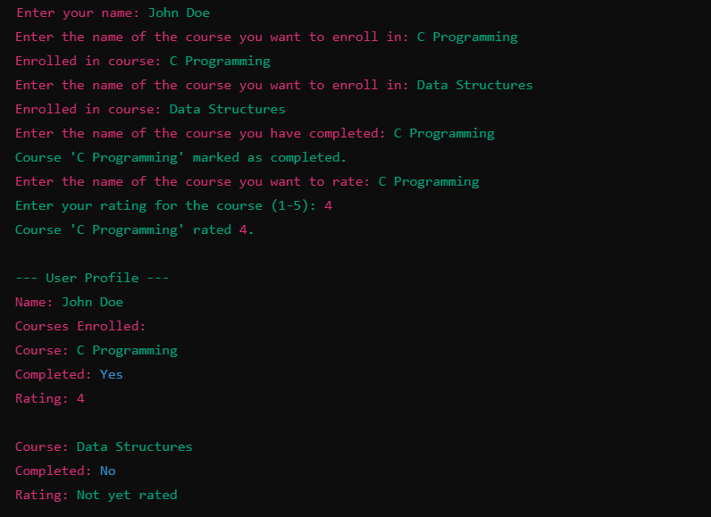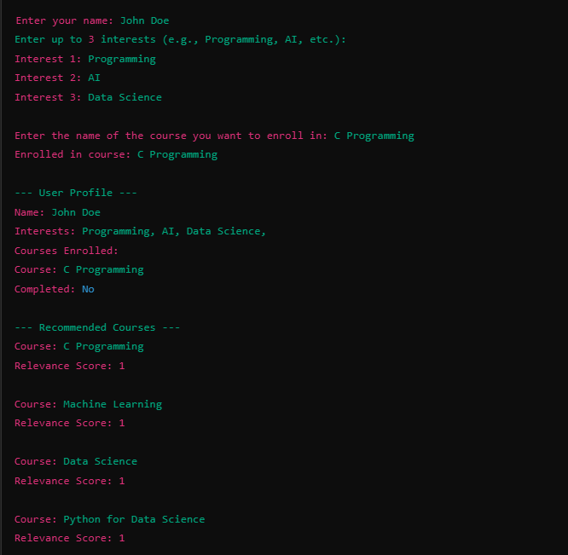

**ENGINEERING STANDARDS:**

ISO/IEC 9899 is the international standard for the **C programming language**. It outlines the specification for writing portable, reliable, and maintainable C programs. Engineering standards based on ISO 9899 provide guidelines and rules for ensuring that C code adheres to a consistent, well-defined structure and follows best practices. These standards cover various aspects of C programming, including syntax, structure, portability, and performance.

**Key Engineering Standards Based on ISO 9899:**

1. **Conformance to ISO/IEC 9899 Standard**
   * Ensure that the C code strictly adheres to the specifications set by ISO 9899 to ensure portability and consistency across different platforms and compilers.
   * Use compliant compilers that support the standard (such as GCC, Clang, or MSVC) and enable strict conformance checking.
2. **Source Code Structure**
   * **Indentation and Formatting:**
     + Code should follow consistent indentation (typically 2 or 4 spaces per indentation level) to enhance readability and maintainability.
     + Brace style should be consistent (e.g., K&R style, Allman style).
   * **File Naming and Organization:**
     + Source code files should have .c extension, header files should use .h.
     + Group related functions together logically in files.
3. **Function Prototypes and Declarations**
   * Always declare function prototypes before use to provide type checking and ensure correct parameter usage.
   * Use explicit return types for functions and specify parameters with their correct types, as per ISO 9899.
4. **Data Types**
   * Always use standard integer types (e.g., int, char, long, etc.) and avoid compiler-specific types to ensure portability.
   * **Fixed-width types:** ISO 9899 defines types like int32_t, uint64_t, etc., to ensure consistent sizes across platforms.
5. **Constants and Macros**
   * **Constant Values:** Prefer using const variables instead of preprocessor #define when possible for type safety and easier debugging.
   * **Macros:** If using macros, ensure they are properly named and encapsulated to avoid naming conflicts. Use inline functions instead of complex macros when appropriate.
6. **Error Handling and Exceptions**
   * ISO 9899 does not natively support exceptions (such as those in C++), so error handling in C is usually done via return values (e.g., NULL, -1) or setting global error states.
   * Check for null pointers, return values, and other failure conditions properly to avoid undefined behavior.
7. **Memory Management**
   * Ensure proper allocation and deallocation of dynamic memory using malloc(), calloc(), and free().
   * Avoid memory leaks by ensuring that every malloc() has a corresponding free().

**Portability**

* + Avoid compiler-specific extensions (e.g., Microsoft-specific keywords or GCC-specific extensions).
  + Use the C standard library (stdio.h, stdlib.h, string.h, etc.) for common tasks like input/output, memory management, and string manipulation.
  + If targeting different platforms, use conditional compilation to handle platform-specific code:

**Pointer Usage**

* + Use pointers correctly and ensure that pointer arithmetic does not go out of bounds.
  + Avoid "dangling" pointers by setting them to NULL after they are freed.
  + Always validate pointer dereferencing to prevent segmentation faults.

1. **Concurrency and Thread Safety**
   * If working with multiple threads, follow proper synchronization techniques such as mutexes, semaphores, and atomic operations.
   * Avoid data races and ensure thread safety, especially when dealing with shared resources.
2. **Standard Library Functions**
   * Always prefer standard library functions (like strlen(), fopen(), strcpy()) over custom implementations for reliability and portability.
   * Be cautious when using functions that may lead to buffer overflows (e.g., gets()) and prefer safer alternatives like fgets().
3. **Functionality and Performance Optimization**
   * While ISO 9899 focuses on correctness and portability, performance optimization should only be done after profiling and identifying bottlenecks.
   * Avoid unnecessary complexity in algorithms to maintain clarity and efficiency.
4. **Compilation and Linking**
   * Follow proper modularization by splitting code into logical files and compiling with appropriate flags.
   * Use #include for header files to share function declarations and structures between source files.
5. **Testing and Debugging**
   * ISO 9899 doesn’t directly address testing, but engineers should use proper debugging and testing techniques, such as unit tests, debugging tools (e.g., gdb), and static analysis tools (e.g., lint).
6. **Code Documentation**
   * Document the code with comments where necessary. The **ISO 9899 standard** encourages clear, concise comments that explain the purpose of code blocks, especially in complex or non-obvious logic.
   * Use comments to explain assumptions, logic, and the role of functions or variables.

Adhering to ISO/IEC 9899 helps ensure that C programs are portable, maintainable, and reliable. Engineers should follow these standards, focusing on writing clear, efficient, and secure code.

**FUTURE SCOPE:**

The future scope of a personalized recommendation system for online learning platforms holds significant potential for improvement and expansion. Here’s a brief explanation of the key areas of future development:

**1. Advanced Recommendation Techniques**

Machine Learning Models: Moving beyond simple collaborative filtering, more advanced techniques such as Deep Learning and Reinforcement Learning can be employed. These methods will help in learning complex user preferences and adapting to them over time.

**2. Enhanced User Profiling**

Dynamic and Multi-dimensional Profiling: Current systems often rely on basic data (like ratings or history). Future systems can utilize richer user profiles incorporating behavior across multiple platforms, such as browsing habits, time spent on specific topics, and interaction with multimedia content.

**3. Gamification and Engagement**

Incorporating Game Mechanics: Features like achievements, badges, and leaderboards can increase user motivation. Rewarding users for completing courses or participating in discussions could make the learning experience more interactive.

**4. Scalability and Performance**

Handling Large Datasets: As the number of users and courses grows, systems need to scale efficiently. Distributed computing, cloud-based architectures, and big data analytics will play a crucial role in ensuring the system can handle large amounts of data and traffic while maintaining performance.

**5.Feedback Mechanisms**

User Feedback Loop: Allow users to rate or provide feedback not just on courses, but also on recommendations. This feedback can be used to refine future suggestions, helping the system to continuously improve.

**6.Real-Time and Context-Aware Recommendations**

Real-Time Personalization: Context-based systems can recommend courses or content dynamically based on real-time factors, such as the user’s location, device, time of day, or even current mood. For example, recommending courses during a user’s downtime or suggesting specific tutorials during live events or webinars.

**7. Diversified Content Recommendations**

Exploring New Topics: To avoid recommendation fatigue, algorithms should suggest diverse content outside the user’s typical interests, fostering broader learning. This could encourage exploration of new areas, leading to a more comprehensive educational experience.

**8. Integration with Emerging Technologies**

AI and Natural Language Processing (NLP): Integration of AI-powered tools like chatbots and NLP can help interpret user queries, recommend content, or even provide real-time tutoring or support.

By addressing these areas, a personalized recommendation system can evolve into a more intelligent, user-centric, and scalable solution, providing richer and more effective learning experiences for users across various domains.

**CONCLUSION:**

In conclusion, the development of a personalized recommendation system for online learning platforms offers a powerful solution to help users navigate the overwhelming volume of available courses and resources. By tailoring course suggestions based on user preferences, behaviours, and learning history, such a system enhances engagement, improves learning outcomes, and fosters a more efficient educational experience.

Looking ahead, the potential for innovation in this space is vast. Advanced techniques like machine learning, enhanced user profiling, and real-time context-aware recommendations will continue to refine the personalization of learning experiences. Incorporating gamification, diversifying content recommendations, and integrating emerging technologies such as AI, VR/AR, and blockchain will further enrich the system, creating dynamic, immersive, and adaptable learning environments. As scalability and performance continue to improve, these systems will be able to support large-scale platforms and accommodate an ever-growing user base.

Ultimately, by addressing evolving user needs and technological advancements, the proposed recommendation system can transform online learning into a more personalized, interactive, and effective journey for learners, positioning it as a cornerstone for future education.